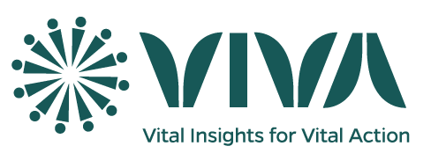**Community Level Supervision**

Community-level supervision is a critical component of the program's quality assurance framework. This level of supervision involves one-on-one guidance, where focal persons and VASA staff accompany CSAs during household data collection. (See the *Provincial Level Supervision* form for cluster selection)

**Activities Upon Arrival in a Community/Cluster:**

* **Engage with Local Leaders:** Contact local leaders to gather information on events and compare with CSAs' reported events.
* **Meet with CSA:** Meet with CSA to be monitored, accompanying them on household visits.
* **Conduct Interviews:** If household members are unavailable, select the next closest household for an interview.
* **Digital Data Collection**: Ideally, use devices for data collection to identify challenges in data collection and transmission.
* **Observe New Event Interviews:** If new events are discovered, observe the CSA conducting the interview.

**Note:** Supervisors can revisit households previously visited by CSAs, informing interviewees that the same questions will be asked to evaluate the CSA's work.

**Post-Data Collection in a Community/Cluster:**

After data collection, supervisors will:

* **Transfer Data:** VASA staff will transfer data to the designated server for data collector monitoring.
* **Data Analysis:** The Central-level team will analyze the data to evaluate the CSA's work quality.
* **Reporting and Recommendations:** The Central-level team will prepare reports on data collector quality and field evaluation, sharing findings with team members and providing recommendations for improvement.